Colonial Soil & Water Conservation District

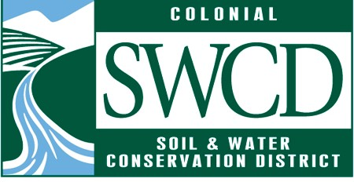

STRATEGIC PLAN FY 2021 – 2024
Colonial Soil & Water Conservation District 205 Bulifants Boulevard Suite C Williamsburg, VA 23188

Table of Contents
Directors and Staff 3
Acronyms and Definition… 4-5
Who We Are 6-7
Introduction: Strategic Planning Process 8
Vision, Mission, and Goals 9
Goals, Objectives, Strategies and Metrics 10-13
Approval Page 14

Directors and Staff

Directors:
Charles Hill Carter III, Charles City County - Chair Robert E. Lund, James City County - Vice Chair Pamela Mason, York County – Secretary
Robert Jeremiah, At Large Director – Treasurer Fred Browning, Charles City County
George Clark, York County
E. Wayne Davis, New Kent County Douglas Hall, James City County David Beals, City of Williamsburg Philip Thomson, New Kent County James Zilius, City of Williamsburg
Megan Tierney, Virginia Cooperative Extension

Staff:
James Wallace, District Manager
Thomas Dunlap, Conservation Specialist II Sheila Jaruseski, Office Coordinator Robyn Woolsey, Urban Conservationist
Tabea Zimmermann, Conservation Specialist I Mackenzie Perkins, Urban Agriculture Tech
Bob Winters, Turf Love Program Tech

Local Government:
Charles City County City of Williamsburg James City County New Kent County York County

Cooperating Agencies:
Virginia Department of Conservation and Recreation (DCR) USDA Natural Resources Conservation Service (NRCS) Farm Service Agency (FSA)
Virginia Department of Forestry (DOF) Virginia Cooperative Extension (VCE)

Acronyms and Their Definitions

AFD—Agricultural Forestal District APW—Annual Plan of Work ASA—Agriculture Stewardship Act
BMP—Best Management Practices. Best Management Practices (BMPs) are effective, practical, structural, or nonstructural methods which prevent or reduce the movement of sediment, nutrients, pesticides and other pollutants from the land to surface or ground water, or which otherwise protect water quality from potential adverse effects of landward activities. For the purpose of this plan, these practices are developed to achieve a balance between water quality protection and the production of agricultural crops within natural and economic limitations.

CBPA—Chesapeake Bay Preservation Act. The Chesapeake Bay Preservation Act, commonly known as "The Bay Act" in Virginia, was adopted by the Virginia General Assembly in 1988. The Bay Act created a cooperative program between the Commonwealth of Virginia and Tidewater local governments to protect and enhance water quality through environmentally responsible land use management.

CDC—Conservation District Coordinator

CREP —Conservation Reserve Enhancement Program

CSWCD—Colonial Soil and Water Conservation District, also referred to as The District. The district is a political subdivision of the State covering Charles City, James City, New Kent and York Counties and the City of Williamsburg. As a result of the Dust Bowl era of the 1930’s legislation was passed that would allow local landowners to form soil conservation districts. The first district was established in 1937. Today, the country is blanketed with nearly 3,000 conservation districts.

DCR—Virginia Department of Conservation and Recreation. DCR conservation district coordinators (CDCs) serve as liaisons between the commonwealth and districts. These coordinators interact daily with district directors and employees, participate at district functions, assist with personnel management matters, oversee fiscal management, and guide NPS programs and activities.

DEQ—Department of Environmental Quality

FSA—Farm Service Agency
JRA—James River Association
NRCF—Natural Resource Commitment Fund RMP—Resource Management Plan

TMDLs—Total Maximum Daily Loads. Under section 303(d) of the Clean Water Act, states, territories, and authorized tribes are required to develop lists of impaired waters. These are waters that are too polluted or otherwise degraded to meet the water quality standards set by states, territories, or authorized tribes. The law requires that these jurisdictions establish priority rankings for waters on the lists and develop TMDLs for these waters. A Total Maximum Daily Load, or TMDL, is a calculation of the maximum amount of a pollutant that a water body can receive and still safely meet water quality standards.

TRC—Technical Review Committee

USDA NRCS—United States Department of Agriculture’s Natural Resources Conservation Service.

VACS—Virginia Agricultural Cost Share

VASWCB—Virginia Soil and Water Conservation Board

VCAP—Virginia Conservation Assistance Program. An urban cost share program provides incentive funding to private owners installing conservation landscaping practices.

VCE—Virginia Cooperative Extension

VDoF—Virginia Department of Forestry

WQIF—Water Quality Improvement Fund

Partner Acknowledgement

The Commonwealth of Virginia supports the Colonial SWCD through financial and administrative assistance provided by the Virginia Soil & Water Conservation Board and the Department of Conservation and Recreation.

Who We Are

The Colonial Soil and Water Conservation District (CSWCD) is a political subdivision of the Commonwealth of Virginia that includes Charles City County, City of Williamsburg, James City County, New Kent County, and York County. Founded in 1947 the district initially included Charles City and New Kent Counties. In 1949 James City County was added to the district. In 1972 York County and the City of Williamsburg were added. CSWCD is one of forty-seven conservation districts within Virginia.

The district is governed by a twelve-member Board of Directors. Ten Directors are elected in the general election every four years and two are appointed. Currently, the staff is composed of seven individuals: A District Manager, a Conservation Specialist II, an Office Coordinator, an Urban Conservationist, a Conservationist Specialist I, an Urban Agriculture Tech, and a Turf Love Program Tech. The district operates on the fiscal year July 1 to June 30.

The district focuses on a wide range of programs encouraging community participation in conserving and protecting soil, water, and related natural resources, with a particular focus on the following:
- Virginia Agricultural Best Management Practices (BMP) Cost-Share Assistance
- Agricultural Conservation Planning and Technical Assistance
- Chesapeake Bay Preservation Act
- Virginia’s Agricultural Stewardship Act
- Environmental & Agriculture Education
- Urban BMP Cost-share and Technical Assistance
- Total Maximum Daily Loads
- Lend technical expertise for design and installation of agricultural conservation practices implemented voluntarily by Virginia farmers.

All constituent citizens can have a voice in resource and conservation planning by attending monthly district meetings and committee meetings, communicating their concerns, and participating in District Programs. Our purpose is to give local citizens the ability to work on conservation problems at the local level. Our philosophy of natural resource management is to provide the necessary technical expertise that assists the community in identifying, discussing, and solving local conservation issues. Our community constituents are farmers, homeowners, teachers, youth, homeowner’s associations, environmental groups, developers, elected officials, local businesses, and civic organizations. We recognize that our constituency base continues to evolve. As such, we strive to remain flexible in developing programs to meet its changing needs.

The Public is invited to attend all Board and Committee meetings consistent with Virginia open meeting law. Notices of District meetings are posted at the following locations:
- District office, 205 Bulifants Boulevard, Suite. 205, Williamsburg VA 23188
- Colonial SWCD Facebook page–Colonial SWCD
- Colonial SWCD website on the Events tab (http://www.colonialswcd.org/events)

Meeting notices are also sent electronically to area libraries with a request to be posted. Area libraries which receive the district’s request include:
- Heritage Public Library, 7791 Invicta Lane, New Kent, VA 23124
- James City County Library, 7770 Croaker Road, Williamsburg, VA 23188
- Williamsburg Regional Library, 515 Scotland Street, Williamsburg, VA 23185
- York County Library, 100 Long Green Boulevard, Yorktown, VA 23693

The programs of the Colonial SWCD will be offered on a non-discriminatory basis, without regard to race, color, natural origin, religion, gender, age, marital status, handicap, or political affiliation.

Introduction: The Strategic Planning Process

The Strategic Plan is a proactive document that is intended to guide the CSWCD through the next four years, from fiscal year 2021 to 2024. It assumes that the future of our organization will be based on changing circumstances and priorities. The purpose of this document is to direct the district toward more effective programs in soil and water conservation within its boundaries.

Overview
The Colonial Soil and Water Conservation District Board and staff underwent a strategic planning process beginning in September 2020 and ending in January 2021. This is, in part, to accomplish the planning requirement from the Virginia Department of Conservation and Recreation due June 2021.

The strategic planning elements reviewed from past plans include the vision and mission, goals, objectives, and strategies. Also discussed during the planning process was the role of the committee structure in the daily decision-making of the district. There was a difference of opinion on the utility of a strong Board committee structure due to the time requirements for the many committee meetings. An ad hoc board group was formed to further discuss the issue. This group agreed and recommended that the present committee structure is fine for the foreseeable future. The Board will revisit the structure once more in the near future.

The Strategic Plan will be used by our Board of Directors, committees, and our staff to develop and manage District programs. The major goal areas are presented in this document to help the District develop its Annual Plans of Work and guide the District’s day-to-day operations. It is our hope that this strategic plan will help the CSWCD meet the challenging future of natural resource conservation in our constituent localities.

Vision

We envision communities served by the CSWCD improving awareness of their natural resources to become even better stewards of water quality and soil health. We believe in an inclusive and integrated approach to conservation
working with partners to support and engage community members consistent with local conservation objectives.

Mission

The CSWCD supports improved and sustainable stewardship of natural resources through programs, technical guidance, outreach, education, and financial assistance.

Goals
Strengthen the District’s Internal Organization Implement a robust education and outreach program
Implement, and where appropriate, expand agricultural programming relative to the district’s constituency while improving community engagement

Increase District opportunities in urban programming

Goal 1: Strengthen the District’s Internal Organization
Objective: Increase interaction and build relationships with local government staff and their public bodies (such as, wetlands boards, CBPA boards, BZA, AFD boards) to advance District programs
Strategy: Directors communicate with elected officials in their localities.
Strategy: Staff communicates with local government staff and officials.
Strategy: Seek opportunities for grant projects that support District goals.
Strategy: Determine the role of the district to address non- District localities in District programming
Objective: Revise Memorandums of Understanding (MOU’s) with localities related to their specific agricultural needs and ordinances
Strategy: Better define the district’s role with localities including the CBPA
Objective: Enhance the District’s capabilities
Strategy: Replace current District vehicle and consider purchase of second District vehicle.
Strategy: Evaluate the current office space needs and consider the District’s Office needs for the upcoming lease renewal
Strategy: Improve staff recruitment, retention, and training opportunities to build skills and knowledge
Strategy: Increase the use of volunteers and interns to meet District Goals
Strategy: Develop a 5-year financial planning document to help guide a sustainable future for the district.
Objective: Develop succession plans and charters for the Board, staff, and committees
Strategy: Implement a process to develop plans and charters for each Committee by December 2021
Metrics:
- Develop a 5-year financial plan by January 1, 2022
- Complete the Committee charters and succession plans by December 2021
Goal 2: Implement a robust education and outreach program
Objective: Increase District outreach efforts using online platforms
Strategy: Regularly update and refine the district’s website and social media presence and assess effectiveness
Strategy: Use online platforms for District announcements and information
Strategy: Develop online application processes for certain District programming
Objective: Support urban agriculture education efforts
Strategy: Provide conservation and agricultural education opportunities during events led by WCG, or other partners
Strategy: Implement educational conservation demonstrations onsite at WCG
Objective: Expand promotion of conservation educational programming Strategy:

Strategy: Continue to sponsor an Envirothon team for the Colonial District and seek expansion to other schools throughout the district
Strategy: Increase public advertising for programming and direct connections with teachers and administrators within locality school systems.
Objective: Increase community accessibility to District programming Strategy: Increase District participation in community events
Strategy: Explore opportunities for more widely accessible conservation programs that do not require financial input or land ownership
Strategy: Adapt existing and develop new educational and outreach resources appropriate for diverse audiences within the district
Objective: Continually assess and better define the role of the education and outreach committee
Strategy: Develop an assessment report with recommendations by August 1, 2021
Strategy: Execute assessment report by June 30, 2022
Objective: Continually seek grant funding to support education and outreach
Strategy: Research opportunities to learn about funding programs and maintain awareness of funding availability
Strategy: Identify roles and tasks that may be expected of a future outreach-focused staff position to be used for funding requests
Metrics:
- Develop process for the Outreach and Education assessment report by August 1, 2021
- Develop and present outreach materials to three targeted audiences by June 30, 2022
- Participate in three educational efforts with WCG by January 2022
- Develop and implement an online outreach plan to increase community awareness of District programming by December 2021
Goal 3: Implement, and where appropriate, expand agricultural programming relative to the district’s constituency while improving community engagement.
Primary Objective: Maintain high quality execution of continuing agricultural programming
Strategy: Seek efficiencies to streamline program execution
Strategy: Maintain and build effective working relationships with agricultural program partners
Secondary Objective: Explore new programming opportunities within the agricultural arena through dedication of staff time and resources
Strategy: Assess program blind spots and wherever possible collaborate with agency partners
Strategy: Pursue funding opportunities to support new programming opportunities
Metrics:
- Fulfill annual grant obligations and Memorandums of Understanding
- Collaborate with partners to provide one educational event/field tour by June 30, 2022
Goal 4: Increase District opportunities in urban programming
Objective: Improve the VCAP application process
Strategy: Assess the viability of VCAP programming, by an internal review, if support from localities or other entities is not secured
Strategy: Review the application criteria and process with improvements by December 31, 2021
Objective: Explore the expansion of the Turf Love program to other localities
Strategy: Contact District member localities to ascertain the interest level and host meetings as appropriate
Strategy: Consult other Districts to acquire program information and resources
Objective: Develop a pilot shoreline management and coastal resiliency program for shorefront property owners
Strategy: Work with and provide training for local volunteer groups to develop a Shoreline Evaluation Program (SEP) to assess shoreline issues and provide opportunities for improved property management
Strategy: Seek grant funding and/or locality support for SEP and potential living shoreline assistance programs
Objective: Continually assess and improve equitability of offering processes for programs and recruitment
Strategy: Review communication channels used and seek effective additions to reach underserved or overlooked audiences
Strategy: Develop and implement a process to network with groups/members of diverse populations or organization
Strategy: Investigate opportunities to engage rental environments
Objective: Consider opportunities beyond District boundaries & three above listed programs
Strategy: Explore partnering opportunities with adjacent and perhaps nearby Districts
Strategy: Resume exploratory discussions with localities unserved by a District adjacent to us and perhaps nearby
Strategy: Investigate & consider adoptability of programs currently offered by other Districts
Metrics:
- Review the VCAP application process and determine any program process changes by December 2021
- Apply for project funding for a living shorelines program by December 2022
- Host two training sessions for SEP volunteers by June 2021

Approval Page

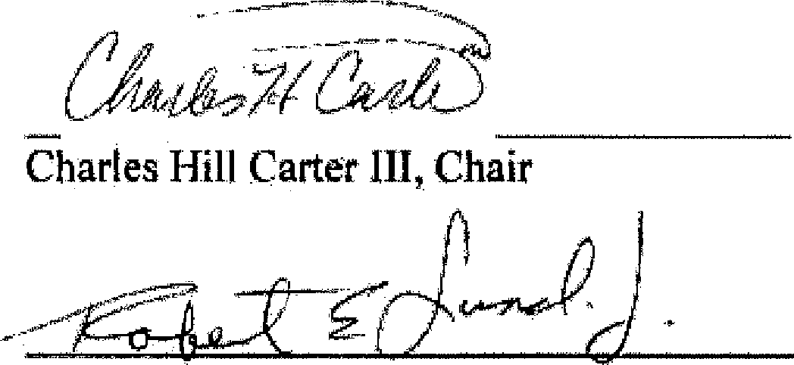
Robert E. Lund Jr, Vice Chair

Robert J. Jeremiah Treasurer

P M ­

Pamela Mason, Secretary
March 01. 2021.

Date

MAn:.l, . · 'ptZ/
Date

March 2.2 202l
Date

_Marth 23, 2021 -
Date

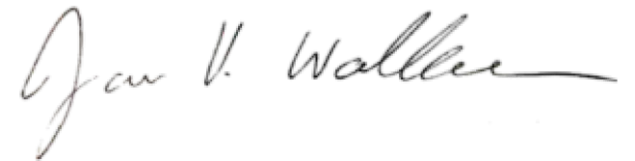
March 23, 2021

James Wallace District Manager

Date

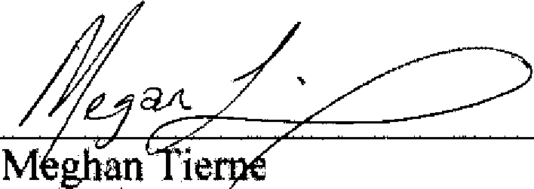
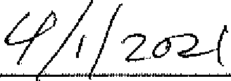
Virginia Cooperative Extension Date

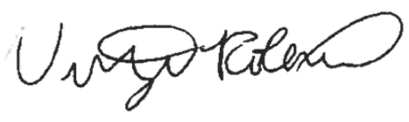
Approved:
Conservation District Coordinator

Department of Conservation and Recreation
4/1/2021

Date

