COLONIAL SOIL AND WATER CONSERVATION DISTRIC
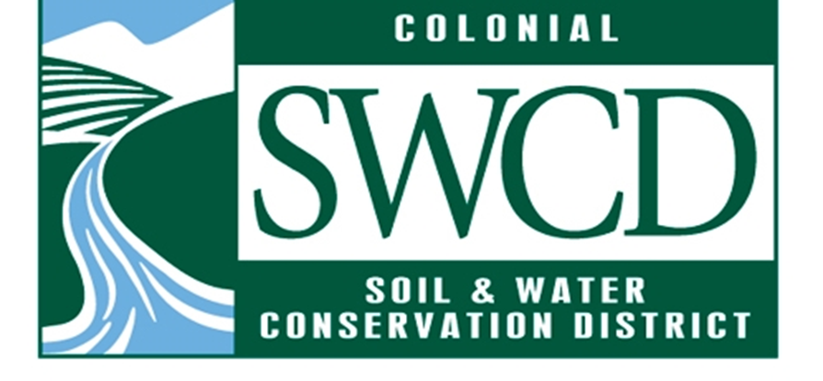
ANNUAL PLAN OF WORK FY 2023
The Colonial Soil & Water Conservation District Annual Plan of Work for fiscal year 20223provides the structure for the pursuit and implementation of goals and objectives. The goals, objectives, and strategies were determined by standing committees, reviewed and revised by the Planning Committee, and approved by the District board.
The successful achievement of the goals will depend on the participation and cooperation of District staff and board working together with District landowners and partners. CSWCD Standing Committee members will play a key role in establishing priorities and timelines for projects and activities that can efficiently and effectively accomplish the various goals and objectives outlined in this plan.
Committees will provide regular and timely updates to the Board on sources of additional funding, potential community partners, as well as barriers and impediments that influence project success.

Executive Committee
Time Frame | Actions – Text in Bold represents Strategic Plan Metric
July 1, 2022 to June 30 2023 | Review charge and charter of committees and officers and provide suggested updates to Board to take action for changes to charges/charters.

Ag Program Committee
Time Frame | Actions – Text in Bold represents Strategic Plan Metric
July 1, 2022 to June 30, 2023 | Prioritized as Follows:  1) Implement VACS FY 2023 Programming  a) Develop, approve, and submit VACS Average Cost List forPY23  b) Determine if/how much of the VACS FY23 Allocation to  accept vs. redistribute  c) Seek to allocate 90% or more of the FY23 Allocation accepted  d) Seek to Complete carry-over practices approved in FY22  e) Conduct promotional/outreach/marketing event for FY23  2) Seek to attain/maintain technical certifications  3) Implement Chesapeake Bay Preservation Act Work  a) Provide technical assistance to localities by engaging with  landowners to address conservation concerns and developing  Conservation Plans  b) Identify parcels and execute CBPA Ag Land Assessments  c) Further refine district’s role in assisting localities with Ag  provisions of CBPA  d) Refine and/or amend CBPA MOUs with Localities  4) Explore Small Farm Programming Opportunities -  a) Develop a Strategy to provide services to small-scale  agricultural operations (including defining terms for our  purposes)  b) Collaborate with VCE ANR Agent, VSU SFOP Agriculture  Management Agents, and relevant partners to provide  technical assistance to small farming operations  5) Explore Grant and Partnership Opportunities – possible sectors  include but are not limited to traditional ag sector, carbon and  energy exchanges, emerging technologies, small farms...  6) Organize education opportunity for District Board and relevant partners

Outreach Education Programs Committee
Time Frame | Text in green represents an Envirothon deliverable
Ongoing Throughout Fiscal Year | - Continue implementation of the USDA Farm to School grant in partnership with Williamsburg Community Growers (ongoing throughout the fiscal year)  Explore opportunities for partnership development related to small farm outreach efforts; consider developing and sharing a small farm needs assessment survey
July 1 – September 30, 2022 | - Begin development of a short educational video to be featured on the website and Facebook page  - Submit Chesapeake Bay License Plate grant for new Enviroscape model and other educational resources  - Advertise VASWCD Poster Contest with local K-12 students and scout troops (posters must be submitted to VASWCD by 10/14/22)  - Develop job description for future outreach staff person  - Choose locations and dates for the 2023 Envirothon competition and training event  - Strategize opportunities for engagement with new teachers, students, and teams  - Begin contacting potential volunteer resource experts  - Submit Envirothon grant to VASWCD  - Host initial Area 3 Envirothon Committee planning meeting
October 1– December 31, 2022 | - Finalize educational video and publish it on the website and Facebook page  - Design and order wearables & giveaways to be used at spring outreach events  - Develop outreach strategy for Youth Conservation Camp and VASWCD scholarship opportunity  - Host 1-2 more Area 3 Envirothon Committee planning meetings and assign volunteer tasks  - Confirm participation for resource experts and seek oral presentation judges
January 1 – March 31, 2023 | - Participate in spring outreach events as scheduling allows (i.e., FidoFest, Farmers Markets)  - Implement outreach strategy for Youth Conservation Camp & VASWCD Scholarship  - Host Envirothon training  - Finalize event documents, including registration forms and competition rules  - Order t-shirts, student recognition items, prizes, and gifts for resource volunteers  - Finalize caterer for lunch
April 1 – June 30, 2023 | - Continue participation in spring outreach and Earth Day events  - Host Envirothon competition  - Seek feedback with a post-competition survey to participants, volunteers, judges, and resource experts  Host de-brief meeting with Area 3 Envirothon committee
Urban Programs Committee
Time Frame | Actions – Text in Bold represents Strategic Plan Metric
July 1, 2022 to June 30 2023 | - Continue implementing Turf Love in JCC consistent with funding from and commitment to JCC  - Continue implementing Turf Love in Williamsburg consistent with funding from Williamsburg  - Work with New Kent on establishing Turf Love there in FY 2024 as resources allow.  - Continue implementing VCAP across district consistent with technical assistance funding from Virginia and localities.  - Continue board member interactions with local decision makers and staff  - Implement SEP  - Collaborate with WCG & Outreach/Education Committee to seek funding to continue Urban Agriculture Technician beyond FY 2023.  - Execute SEP & Living Shoreline focused NFWF Small Watershed Grant if funded  - Continue to seek improved funding for SEP, Turf Love, and VCAP  - Continue to seek novel ways to engage local government officials in collaborating with Outreach/Education Committee  - Review committee charge/charter and provide updates to District Manager, as necessary.  - Execute or continue seeking to establish MOU for Colonial provided program(s) to Hampton and locality funding for program(s)  - Continue seeking to establish MOU for Colonial provided program(s) to other nearby localities without District support) and locality funding for program(s)  - Reach out to more diverse pool of supporting volunteers for and potential applicants with offered programs trying at least one of following strategies:  - Review communication channels used and seek effective additions to reach underserved or overlooked audiences  - Develop and implement a process to network with groups/members of diverse populations or organization  - Investigate opportunities to engage rental environments  - Continue efforts to more efficiently implement VCAP.  - Continue to consult other Districts to acquire information about and resources for current and potential new to Colonial programs  Explore opportunities for mutually beneficial partnering with other Districts.

Finance Committee
Time Frame | Actions – Text in Bold represents Strategic Plan Metric
July 1, 2022 to June 30, 2023 | - Develop a 5-year financial needs assessment to sustain District operations  - Complete deliverables of FY 2023 DCR Operations Grant  - Evaluate current office space and alternative options  - Submit budget requests to each of the district’s member localities for FY 2024 funding  - Review committee charge/charter and provide updates to District Manager, as necessary. Board will take action to approve committee charges/charters  - Develop a strategy for the future of our equipment (Ford truck, tractor, bush hog, tiller, disk, trailer)

Nominating Committee
Time Frame | Actions – Text in Bold represents Strategic Plan Metric
July 1, 2022 to June 30 2023  October 1 – December 31 2023 | - Fill Appointed At-Large Director Position  - Provide slate of officers for upcoming year before last BoD meeting of 2023  • Review committee charge/charter and provide updates to District Manager, as necessary. Board will take action to approve committee charges/charters  • Discuss with current officers (Chair, Vice Chair, Secretary and Treasurer) to determine if they would like to serve in their respective roles for another calendar year. If not, begin discussions with members of the Board of Directors to obtain suitable volunteers.

Personnel Committee
Time Frame | Actions – Text in Bold represents Strategic Plan Metric
July 1, 2022 to June 30 2023 | - Make Human Resources a priority.  1. Director and staff training  2. Host presentations from jurisdictional HR staff and/or HR consultant(s)  - Restructure/Reduce the size of the Personnel Committee  - Consider changing the charter of the Personnel Committee to include personnel, policy, and planning

Planning Committee
Time Frame | Actions – Text in Bold represents Strategic Plan Metric
July 1, 2022 to June 30 2023 | - Develop the FY 2023 APOW with input from committees & staff  - Review FY 2023 APOW-to be done quarterly in APOW 2023  - Review Strategic Plan-to be done bi-annually in APOW 2023  - Review committee charge/charter and provide updates to District Manager, as necessary.  - Continue Succession Planning for Directors and Staff in the first quarter of FY 2023  - Ask the VASWCD to develop and provide Strategic Plan and APOW development training for districts – both directors and staff. This is an important skill set that districts need.  Discussion and perhaps planning for District Banquet

Operations/Staff
Time Frame | Actions – Text in Bold represents Strategic Plan Metric
- Execute lease agreement for district office space
- Hire new staff member dedicated to outreach,
marketing, and communications
- Schedule and conduct training for directors and
staff to address HR needs
- Plan and execute the district’s recognition banquet
- Complete 3 quarterly staff check-ins/coaching
sessions
- Complete annual staff performance evaluations

The Commonwealth of Virginia supports the Colonial Soil & Water Conservation District though financial and administrative assistance provided by the Department of Conservation & Recreation. The Virginia Soil and Water Conservation Board supports the Colonial Soil and Water Conservation District through their oversight and support, including financial support, coordination and information exchange.
All programs and services of the Colonial Soil & Water Conservation District are offered on a nondiscriminatory basis without regard to race, color, national origin, religion, sex, age, marital status or handicap.

Approved by the Colonial Soil & Water Conservation District Board of Directors on July 26, 2023

Colonial Soil & Water Conservation District
Chairman of the Board, Charles Carter

Signed______________________________________Date___________________

